Day 16 EMP_ID 112916146
Task 👍1:
Write an algorithm / steps for selection sort.
- Perform loop i from 0 to n-2
- Assume i as min
- Find real min in j = i+1..n-1
- Swap minimum with i
- i++ and repeat
After last pass, array gets sorted.

Task 2:

Write a pseudo code for the selection sort
Algorithm: Selection-Sort(A)

Input: Array A of length n
Output: A sorted in ascending order

for i ← 0 to n−2 do
minIndex ← i
minValue ← A[i]

// Find the smallest element in the unsorted part
for j ← i+1 to n−1 do
if A[j] < minValue then
minIndex ← j
minValue ← A[j]
end if
end for

// Place the smallest element at position i
A[minIndex] ← A[i]
A[i] ← minValue
For block end

Task 4

void bubbleSort(int[] arr) {
int n = arr.length;
// Outer loop: each pass moves the next largest element to its correct position
for (int i = 0; i < n - 1; i++) {
// Inner loop: compare adjacent elements
for (int j = 0; j < n - i - 1; j++) {
if (arr[j] > arr[j + 1]) {
// Swap pair if out of order
int temp = arr[j];
arr[j] = arr[j + 1];
arr[j + 1] = temp;
}
}
}
}

Task 3

public class SelectionSortExample {
public static void main(String[] args) {
int[] a = {64, 25, 12, 22, 11};

// print before
System.out.println("Before: " + java.util.Arrays.toString(a));

// sort
for (int i = 0; i < a.length - 1; i++) {
int min = i;
for (int j = i + 1; j < a.length; j++) {
if (a[j] < a[min]) {
min = j;
}
}
int temp = a[i];
a[i] = a[min];
a[min] = temp;
}

// print after
System.out.println("After: " + java.util.Arrays.toString(a));
}
}

n = length(A)
Repeat

Assumed the array is sorted
swapped ← false
for i from 0 to n - 2 do
if A[i] > A[i + 1] then
swap A[i] and A[i + 1]
swapped ← true
end if block
end for block
n ← n - 1 // largest element is now in place
until swapped = false
end procedure

Task 6

import java.util.Arrays;

public class BubbleSortExample {
public static void bubbleSort(int[] arr) {
int n = arr.length;
boolean swapped;

for (int i = 0; i < n - 1; i++) {
swapped = false;

// Bubble largest unsorted element to its correct place
for (int j = 0; j < n - 1 - i; j++) {
if (arr[j] > arr[j + 1]) {
int temp = arr[j];
arr[j] = arr[j + 1];
arr[j + 1] = temp;
swapped = true;
}
}

// If no swaps occurred, the array is already sorted
if (!swapped) break;
}
}

public static void main(String[] args) {
int[] data = {64, 34, 25, 12, 22, 11, 90};
System.out.println("Before sorting: " + Arrays.toString(data));

bubbleSort(data);

System.out.println("After sorting: " + Arrays.toString(data));
}
}

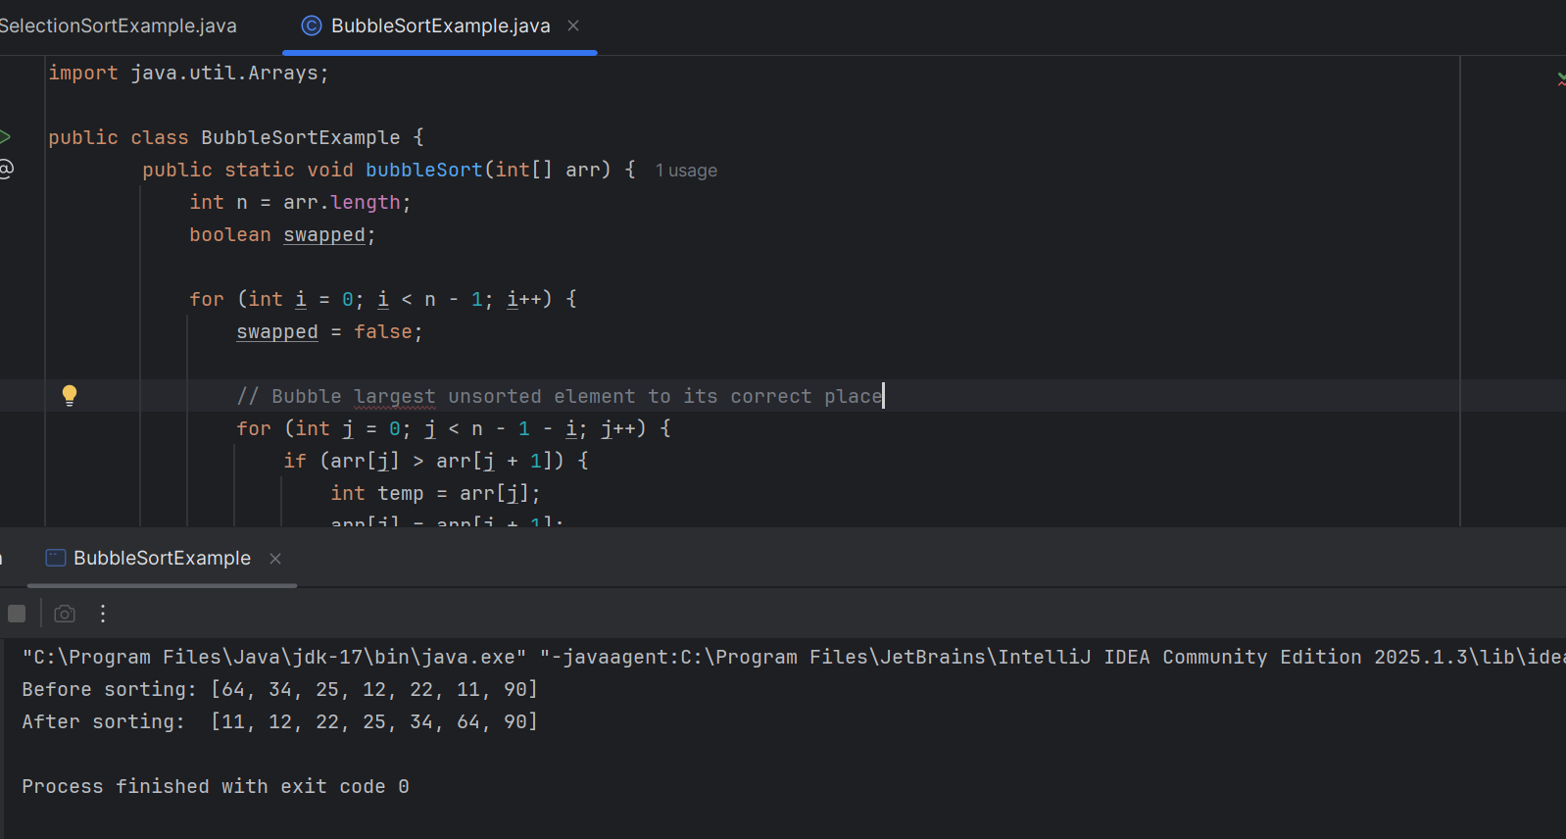

Task 7

Algorithm (Steps)
- Assume the first element is in the sorted portion.
- For each subsequent element (from index 1 to end):
  - Let key be this element.
  - Compare key with elements in the sorted portion (to its left).
  - Shift any larger elements one position to the right.
  - Insert key into the now-vacant correct spot.
- Repeat until the entire list is sorted.

Task 8

Insertion-Sort(A):
for j = 1 to length(A) - 1
key ← A[j]
i ← j - 1
while i ≥ 0 and A[i] > key do
A[i + 1] ← A[i]
i ← i - 1
A[i + 1] ← key

Task 9
public class InsertionExample {
/** Sorts the array in-place using insertion sort */
public void sort(int[] arr) {
int n = arr.length;
for (int i = 1; i < n; ++i) {
int key = arr[i];
int j = i - 1;

// Shift elements greater than key one position ahead
while (j >= 0 && arr[j] > key) {
arr[j + 1] = arr[j];
j = j - 1;
}
arr[j + 1] = key;
}
}

/** Utility method to print the array */
public static void printArray(int[] arr) {
for (int num : arr) {
System.out.print(num + " ");
}
System.out.println();
}

/** Main method to demo insertion sort */
public static void main(String[] args) {
int[] arr = { 12, 11, 13, 5, 6 };

InsertionExample sorter = new InsertionExample();
System.out.print("Before sorting: ");
printArray(arr);

sorter.sort(arr);

System.out.print("After sorting: ");
printArray(arr); // Expected output: 5 6 11 12 13
}
}

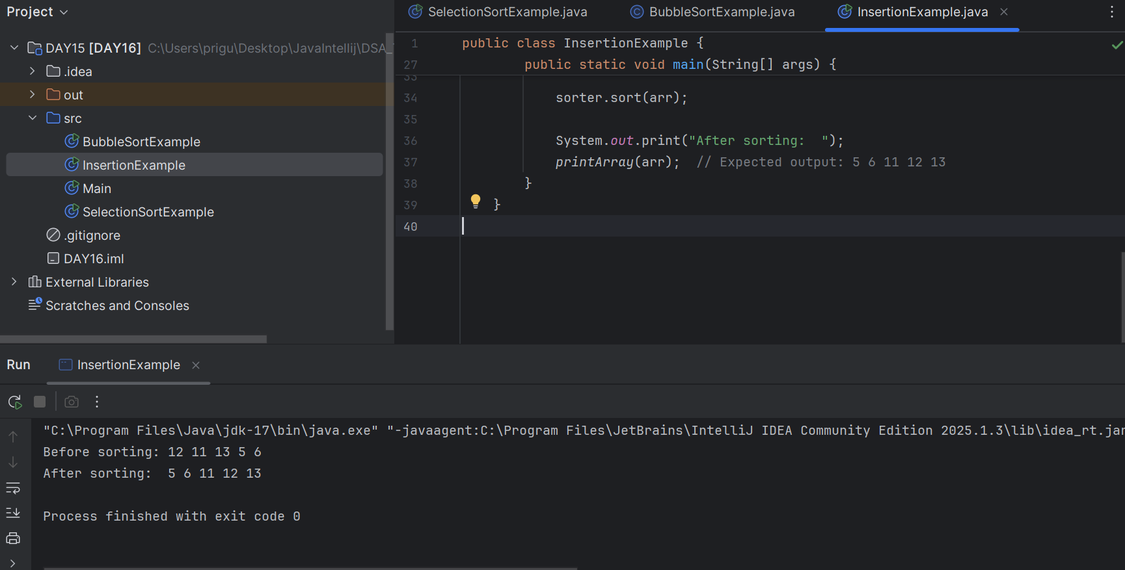

Task 10
Advantages

- Super simple to understand
Just compare neighbors and swap if needed—easy to learn and code
- In-place sorting
Doesn’t need extra space—sorts the array in itself (only uses a tiny amount for swapping)

- Stable algorithm
Items that are equal stay in the same order they started in .
- Adaptive with small optimization
If the list is already sorted or almost sorted, it stops early and runs fast (~O(n))
- Works well for tiny data
For very small lists (like up to 10 items), it can be good enough

Disadvantages
- Super slow for larger lists
It keeps comparing for every pair—makes it O(n²), which gets awful as data grows.
- Extra swaps and comparisons
Even once sorted, it might still do useless work unless you add a “stop early” trick
- Bad with reverse-ordered data
If the data is in reverse, it'll take the longest possible time to fix it
- Not practical for real use
Almost never used in real apps—better choices like QuickSort or MergeSort are way faster
- Not hardware-friendly
On modern CPUs, it does lots of slow memory operations and branches more than better algorithms

Task 11

Merge Sort is a Divide and Conquer algorithm.
- Divide the array into two halves.
- Sort both halves recursively.
- Merge the two sorted halves.

Task 12
MERGE-SORT(arr, left, right):
if left < right:
mid ← floor((left + right) / 2)
MERGE-SORT(arr, left, mid)
MERGE-SORT(arr, mid + 1, right)
MERGE(arr, left, mid, right)

MERGE(arr, left, mid, right):
i ← left
j ← mid + 1
temp ← empty list

while i ≤ mid and j ≤ right:
if arr[i] ≤ arr[j]:
append arr[i] to temp; i ← i + 1
else:
append arr[j] to temp; j ← j + 1

while i ≤ mid:
append arr[i] to temp; i ← i + 1
while j ≤ right:
append arr[j] to temp; j ← j + 1

// Copy sorted values back
for k from left to right:
arr[k] ← temp[k − left]

Task 13

public class MergeSortingExample {
// Sorts the array arr[left..right] using merge sort
public static void mergeSort(int[] arr, int left, int right) {
if (left < right) {
int mid = (left + right) / 2;
mergeSort(arr, left, mid); // sort left half
mergeSort(arr, mid + 1, right); // sort right half
merge(arr, left, mid, right); // merge sorted halves
}
}

// Merges arr[left..mid] and arr[mid+1..right]
public static void merge(int[] arr, int left, int mid, int right) {
int n1 = mid - left + 1;
int n2 = right - mid;
int[] L = new int[n1], R = new int[n2];

for (int i = 0; i < n1; i++) L[i] = arr[left + i];
for (int j = 0; j < n2; j++) R[j] = arr[mid + 1 + j];

int i = 0, j = 0, k = left;
while (i < n1 && j < n2) {
if (L[i] <= R[j]) arr[k++] = L[i++];
else arr[k++] = R[j++];
}

while (i < n1) arr[k++] = L[i++];
while (j < n2) arr[k++] = R[j++];
}

// Demo run
public static void main(String[] args) {
int[] arr = {12, 11, 13, 5, 6, 7};
System.out.println("Before: " + java.util.Arrays.toString(arr));
mergeSort(arr, 0, arr.length - 1);
System.out.println("After: " + java.util.Arrays.toString(arr));
}
}

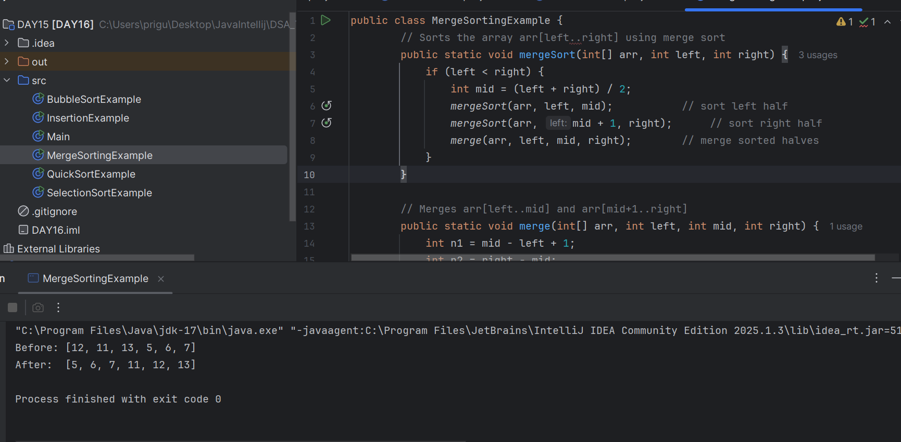

Task 14
AAlgo of Quick Sort

🔶 What is QuickSort?
QuickSort is a divide-and-conquer sorting algorithm.
- Choose a pivot element.
- Partition the array so that:
  - Elements less than pivot go to the left.
  - Elements greater than pivot go to the right.
- Recursively apply the same logic to left and right subarrays.

Task 15

function quickSort(arr, low, high)
if low < high then
pivotIndex ← partition(arr, low, high)
quickSort(arr, low, pivotIndex - 1)
quickSort(arr, pivotIndex + 1, high)

function partition(arr, low, high)
pivot ← arr[high]
i ← low - 1

for j from low to high - 1 do
if arr[j] < pivot then
i ← i + 1
swap arr[i] and arr[j]

swap arr[i + 1] and arr[high]
return i + 1

Task 16

public class QuickSortExample {

public static void quickSort(int[] arr, int low, int high) {
if (low < high) {
int p = partition(arr, low, high);
quickSort(arr, low, p - 1);
quickSort(arr, p + 1, high);
}
}

private static int partition(int[] arr, int low, int high) {
int pivot = arr[high];
int i = low - 1;
for (int j = low; j < high; j++) {
if (arr[j] <= pivot) {
i++;
swap(arr, i, j);
}
}
swap(arr, i + 1, high);
return i + 1;
}

private static void swap(int[] a, int i, int j) {
int tmp = a[i];
a[i] = a[j];
a[j] = tmp;
}

public static void main(String[] args) {
int[] arr = {10, 7, 8, 9, 1, 5};
quickSort(arr, 0, arr.length - 1);
System.out.println(java.util.Arrays.toString(arr));
}
}

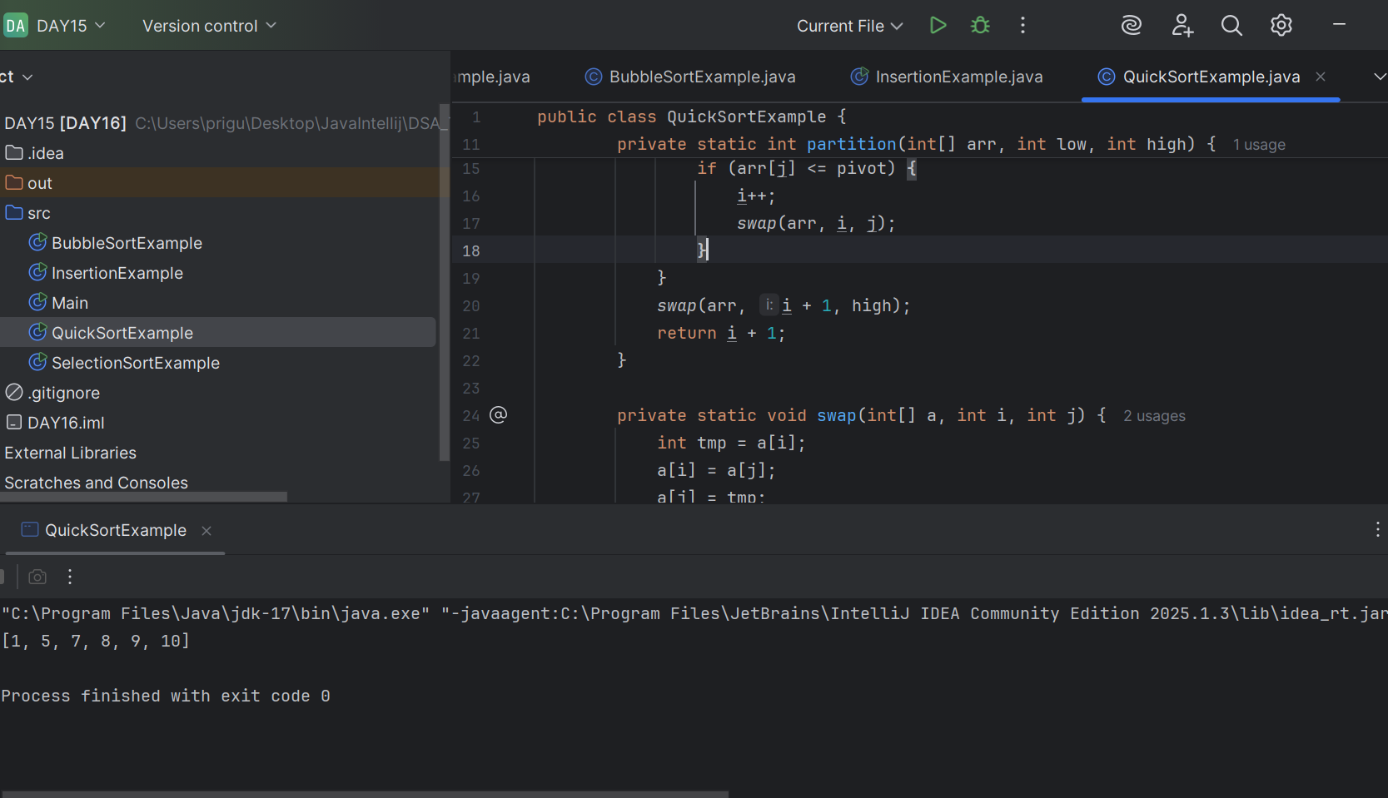

Task 17

In industrial or real-world applications, Merge Sort is far superior to Bubble Sort in terms of time complexity and scalability:
- Merge Sort wins every time on medium to large datasets due to consistent O(n log n) time.
- Bubble Sort is impractical beyond small, nearly-sorted lists due to O(n²) complexity.
- In industrial-grade software, Merge Sort (or hybrids based on it) is the standard choice for robust performance.

Task 18
Time Complexity: O(m + n)
Space Complexity: O(1)

Task 19:

This code is going overflow of stack.. Can you plz help me fix it guys.. :

public class RecLoop {

public int calc(int n) {
if (n == 0) return 0;
return n + calc(n);
}

psvm(String[] args) {
System.out.println(new RecLoop().calc(10));
}
}

Sol : n needs to be decreased, infinite recursive loop as it wont be able to touch the base condition.

Task 20 **If the array is unsorted**:
No. Don’t use binary search—we ’ll get wrong results.
For unsorted data, use linear search, which takes O(n) time but is always correct.
If the array is sorted (or kept sorted):
Yes. We can use binary search safely, with O(log n) time complexity .

Reason : Binary search cannot be used on unsorted arrays—it will almost certainly produce wrong indices or -1. Stick to linear search if your data isn’t sorted. If you need repeated fast searches, sort once and then use binary search going forward.

